**Capstone Project**

**Opening an Iranian Restaurant in Hamburg**

**Introduction**

Hamburg is one of a big and international city of Germany. is the second-largest city in Germany after Berlin, as well as the overall 7th largest city and largest non-capital city in the European Union with a population of over 1.84 million. Hamburg's urban area has a population of around 2.5 million[ and its metropolitan area is home to more than five million people. The city lies on the River Elbe and two of its tributaries, the River Alster and the River Bille. Aside from its rich architectural heritage, the city is also home to notable cultural venues. So potential stablishment of traditional restaurant in this city is an interesting topic. The city consists of seven sections as below:

* **Section 1***:*  Hamburg-Mitte
* **Section 2**:Altona
* **Section 3***:* Eimsbüttel
* **Section 4***:* Hamburg-Nord
* **Section 5***:* Wandsbek
* **Section 6***:* Bergedorf
* **Section 7***:* Harburg

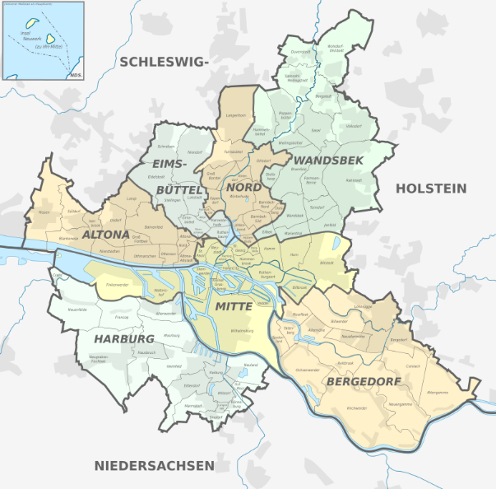

**Problem**

In this project, I will investigate potential opening an Iranian restaurant in Hamburg and the proper neighborhood.

**Interest**

Anyone wants to open a new business in any geographic location may be interested in this project by modifying search criteria.